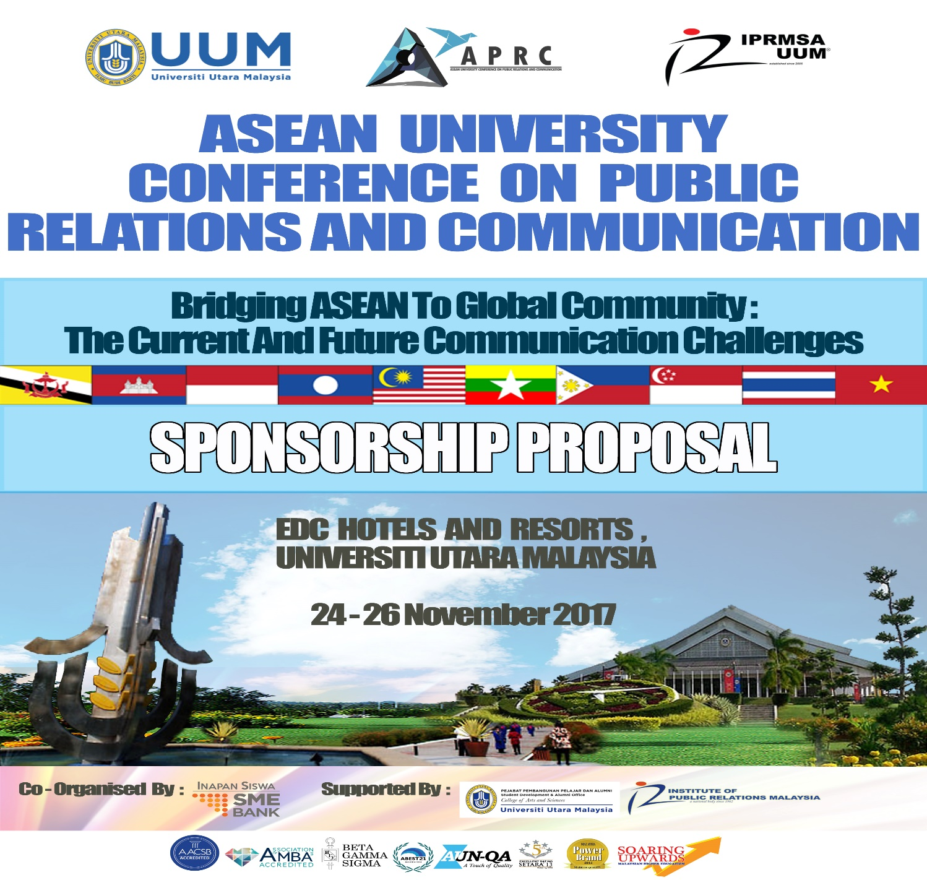

Secretariat – APRC ’17
School of Multimedia Technology & Communication, Universiti Utara Malaysia, 06010 UUM Sintok, KEDAH DARUL AMAN, MALAYSIA

Telephone: +604-9285928 Fax: +604-9285804
aprc2017.weebly.com , E-mail: aprcuum17@gmail.com

SPONSORSHIP INVITATION AIMS

The aim of the sponsorship inivitaion is to build a synergy partnership between [company name] and IPRMSA-UUM by sponsoring the APRC 17.

It also gives opportunity to APRC’17 committee members to apply their knowledge in event management and public relations.

2.0 WHEN AND WHERE?

APRC’17 will be held in EDC Hotel and Resort, Universiti Utara Malaysia, Kedah on the 24-26 November 2017. Please refer to the website (aprc2017weebly.com) for further information on APRC’17.

3.0 BACKGROUND

The Institute of Public Relations Malaysia Student Association –Chapter UUM (IPRMSA-UUM Chapter) in collaboration with the Student Development and Alumni Office (PPA), College of Arts & Sciences, UUM intends to organize a third conference at the international level to provide a platform for students’ dialogues and knowledge sharing, particularly among the ASEAN member countries. We received overhelming responses for the past two conferences from ASEAN universities with 298 participations.

Malaysia’s relationship with the ASEAN member countries encompasses various areas ranging from developing entrepreneurship, enhancing education, embracing cultures to establishing close relations. In order to disseminate further cross-border prosperity among neighboring ASEAN nations, the IPRMSA-UUM Chapter plans to hold a conference for improving the edification of students of institutions of higher learning in ASEAN countries, particularly Public Relations and Communication students.

The ASEAN University Conference on Public Relations and Communication (APRC) aims to provide the avenue particularly for public relations and communication students of the institutions of higher learning institutions from ASEAN member countries to engage in a discussion focusing Bridging Asean To Global Community: The Current And Future Communication Challenges. The rapid process of globalisation in the 21st century has created new challenges for the practice of public relations and communication. One of the challenges is existence of new media has influenced the style of communication nowadays. This trend certainly necessitates a re-thinking in how professionals strategise public relations network and communication activities deal with this issue. As such, this conference is vital for students as future practitioners to contribute into thinking through networking strategies for the development of public relations and communication that must consider how they deal with current and future communication challenges.

The ASEAN platform that is set for this conference offers opportunities for students with the interest in public relations and communication to discuss issues regarding ASEAN partnerships. Such discussion will benefit students in developing their potentials and intellectual capacity for the future.

4.0 OBJECTIVES OF APRC 2017

The objectives of APRC 2017 are as follows:

- To provide a room for dialogue among public relations and communication students.
- To build a better relationships among students with the theme of "ASEAN BRIDGING TO THE GLOBAL COMMUNITY: THE CURRENT AND FUTURE CHALLENGES COMMUNICATION"
- To provide a platform for students in Malaysia and ASEAN countries to discuss and share knowledge on the development in the field of public relations and communications.
- To foster a positive relationship among students in different cultures and countries.
- Creating a vision of peace, harmony and cooperation among higher education institutions in the region.
5.0 TARGET GROUP
The conference targets the participation from various groups particularly academicians, public relations practitioners, government and non-government bodies, students and individuals. Keynote speakers and the paper presenters are from public relations and communication practitioners, policy makers and academicians.

6.0 CONTRIBUTION CATEGORIES

Platinum Sponsor – RM30, 000*
- The company’s logo will be printed on the front page of the conference’s souvenir booklets, proceedings and files.
- An A4 size (11 inches x 8.5 inches) colored advertisement at the back of the conference’s souvenir booklets (advertisement artwork prepared by the company)
- The company’s logo will be placed on each backdrop of the Conference Hall and the plenary rooms.
- The company’s logo will be placed on each promotional banners of the conference.
- Verbal note of appreciation during the conference.
- The company’s logo and website will be linked to the conference’s website.
- The rights of distributing brochure on the company’s product and services during the conference.
- Free booth at the conference
- Free participation of 5 of the company’s representative in the conference.

Gold Sponsor – RM20, 000*

- The company’s logo will be printed on the front page of the conference’s souvenir booklets, proceedings and files.
- An A4 size (11 inches x 8.5 inches) colored advertisement at the back of the conference’s souvenir booklets (advertisement artwork prepared by the company)
- The company’s logo will be placed on each backdrop of the Conference Hall and the plenary rooms.
- The company’s logo will be placed on each promotional banners of the conference.
- Verbal note of appreciation during the conference.
- The company’s logo and website will be linked to the conference’s website.
- The rights of distributing brochure on the company’s product and services during the conference.
- Free booth at the conference
- Free participation of 4 of the company’s representative in the conference.

Silver Sponsor – RM15, 000*

- The company’s logo will be printed on the front page of the conference’s souvenir booklets, proceedings and files.
- An A4 size (11 inches x 8.5 inches) colored advertisement on the inner front page of the conference’s souvenir booklets (advertisement artwork prepared by the company)
- The company’s logo will be placed on each backdrop of the Conference Hall and the plenary rooms.
- The company’s logo will be placed on each promotional banners of the conference.
- Verbal note of appreciation during the conference.
- The company’s logo and website will be linked to the conference’s website.
- Free booth at the conference
- Free participation of 3 of the company’s representative in the conference.

Bronze Sponsor – RM10, 000*

- The company’s logo will be printed on the front page of the conference’s souvenir booklets, proceedings and files.
- An A4 size (11 inches x 8.5 inches) colored advertisement on the inner page of the conference’s souvenir booklets (advertisement artwork prepared by the company)
- The company’s logo will be placed on each backdrop of the Conference Hall and the plenary rooms.
- The company’s logo will be placed on each promotional banners of the conference.
- Verbal note of appreciation during the conference.
- The company’s logo and website will be linked to the conference’s website.
- Free participation of 2 of the company’s representative in the conference.

Advertisement Based Sponsorship*

- RM5,000 - An A4 size (11 inches x 8.5 inches) colored advertisement inside the conference’s souvenir booklets (advertisement artwork prepared by the company)
- RM3,500 - An A4 size (11 inches x 8.5 inches) black and white advertisement inside the conference’s souvenir booklets (advertisement artwork prepared by the company)
- RM2,000 - A half page size (5.85 inches x 8.27 inches) black and white advertisement inside the conference’s souvenir booklets
- RM1,000 - A quarter page size (5.85 inches x 4.14 inches) black and white advertisement inside the conference’s souvenir booklets
- RM500 - A business card size (2.8 inches x 4.14 inches) black and white advertisement inside the conference’s souvenir booklets
- Any contribution less than RM500 – the contributor’s name will be listed in the ACKNOWLEDGEMENTS.

Product/Service Based Sponsorship*

- Product/Service Based Sponsorship that exceeds the amount of RM8,000 will received a FREE A4 size (11 inches x 8.5 inches) colored advertisement inside the conference’s souvenir booklets (advertisement artwork prepared by the company)
- Product/Service Based Sponsorship that exceeds the amount of RM5,000 will receive a FREE A4 size (11 inches x 8.5 inches) black and white advertisement inside the conference’s souvenir booklets (advertisement artwork prepared by the company)
- Product/Service Based Sponsorship that exceeds the amount of RM3,500 will receive a FREE a half page size (5.85 inches x 8.27 inches) black and white advertisement inside the conference’s souvenir booklets
- Product/Service Based Sponsorship that exceeds the amount of RM2,500 will receive a FREE quarter page size (5.85 inches x 4.14 inches) black and white advertisement inside the conference’s souvenir booklets
- Product/Service Based Sponsorship that exceeds the amount of RM1,500 will receive a FREE business card size (2.8 inches x 4.14 inches) black and white advertisement inside the conference’s souvenir booklets
- Product/Service Based Sponsorship less than RM1,500 – the contributor’s name will be listed in the ACKNOWLEDGEMENTS.

(Among suggested products needed for the conference are stationeries, files, conference’s bag, caps, books, t-shirt, printing materials and services, souvenirs, drinking water and other relevant products. Products/services contributions are not eligible for the tax deduction.)

*NOTES:
- For all financial contribution towards the conference, cheques and money orders should be made payable to ‘UNIVERSITI UTARA MALAYSIA’ and mailed to:

APRC 2017 Secretariat

IPRMSA UUM Chapter

School of Multimedia Technology and Communication

Universiti Utara Malaysia

06010 Sintok

Kedah Darul Aman

Malaysia
(Attention: Dr. Mohamad-Noor Sharipudin)

SPONSORSHIP CONFIRMATION FORM

Organisation Name: ..................................................................................................

Organisation Contact : ..............................................................................................

Address: ......................................................................................................................

......................................................................................................................................

Telephone: ................................................. Facsimile: ...........................................

Mobile: ....................................................... E-Mail: ..................................................

Website: ......................................................................................................................

I have read the Sponsorship Proposal of Asean University Conference on Public Relations and Communication (APRC’17) and agreed with terms and conditions.

I’m interested in sponsoring APRC’17 as a:
(You can choose more than one category)

PLATINUM SPONSOR RM30,000 GOLD SPONSOR RM20,000

BRONZE SPONSOR RM10,000 SILVER SPONSOR RM15,000

ADVERTISEMENT BASED SPONSOR VALUE OF RM ......................

PRODUCT/SERVICE BASED SPONSOR VALUE OF RM ....................

Enclosed herewith our cheque/postal order/money order for RM ................... being payment to ASEAN UNIVERSITY CONFERENCE ON PUBLIC RELATIONS AND COMMUNICATION (APRC’17). Please make cheque or money order payable to ‘UNIVERSITI UTARA MALAYSIA’

Signature: .................................................... Date: .....................................................
Please forward the completed Sponsorhip Confirmation Form via email, facsimile or mail to:
APRC 2017 SECRETARIAT, IPRMSA UUM Chapter, School of Multimedia Technology and Communication, Universiti Utara Malaysia, 06010 UUM Sintok Kedah. Facsimile: +604-9285804 Email: aprcuum17@gmail.com

8.5 inci

APRC 2017

“BRIDGING ASEAN TO GLOBAL COMMUNITY: THE CURRENT AND FUTURE COMMUNICATION CHALLENGES”

EDC Hotel & Residence
24 - 26 November 2017

APRC 2017

11.0 inci

8.27 inci
ASEAN University Conference On
Public Relations and Communication (APRC)

“BRIDGING ASEAN TO GLOBAL COMMUNITY: THE CURRENT AND FUTURE COMMUNICATION CHALLENGES”

EDC Hotel & Residence
24 - 26 November 2017

2.8 inci

APRC 2017

ASEAN University Conference On
Public Relations and Communication (APRC)

“BRIDGING ASEAN TO GLOBAL COMMUNITY: THE CURRENT AND FUTURE COMMUNICATION CHALLENGES”

EDC Hotel & Residence
24 - 26 November 2016

4.14 inci

APRC 2017

ASEAN University Conference On
Public Relations and Communication (APRC)

“BRIDGING ASEAN TO GLOBAL COMMUNITY: THE CURRENT AND FUTURE COMMUNICATION CHALLENGES”

4.14 inci
5.85 inci
5.85 inci
APRC 2017

