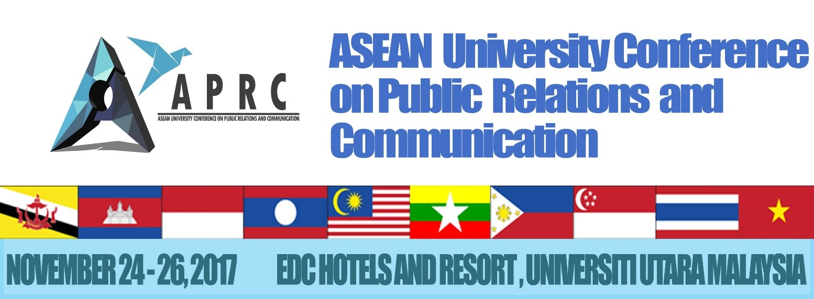
REGISTRATION FORM
SECTION A: PERSONAL DETAILS

Name: | ________________________________________________________________________________
 | (First Name) |  |  |  | (Middle name) |  | (Last Name)
Gender: | Male / Female
Organization/ University: |  |  |  | _____________________________________________________________________
Address: | ________________________________________________________________________________  ________________________________________________________________________________
Country | _______________________________ |  |  |  | Postcode : | ______________________________
Phone: | ________________________________ |  |  |  | _____________________________________
 | (Area Code) |  |  |  | (Phone Number)
Email | _______________________________________________________________________________
Special Requirements: |  |  | _______________________________________________________________________
 |  | (food restriction, etc)
SECTION B: FEES (Please tick appropriate box):

International Participant |  | USD 100
Malaysian Participant |  | RM 400

Payment for Instructions:-
1. By Credit Card (Online)
- Browse UUM e-com (http://e-com.uum.edu.my/bend/paymode.jsp)
- Follow all required steps as instructed. The payment is (USD100 or RM400).
- Note : for 'payment for' choose ‘other payment’
- Note : for 'description' : key in 'IPRMSA - APRC 2017 (Presenter/Participation)'
- Please print and keep the notification of payment made as proof of payment. Scan and email the proof of payment as soon as possible or before 30 October 2017 to the secretariat (aprcuum17@gmail.com). You also need to bring the original payment slip during the registration. You are required to show the proof of payment to the secretariat on the registration day of the conference/ workshop/ colloquium. Failure to do so will result in your name being not listed as presenter/ participants.
2. Telegraphic Transfer / Bank Transfer
Transfer should be made to the following account:
Account Name: UNIVERSITI UTARA MALAYSIA
Account No.: 02093010000010
Bank Name: BANK ISLAM MALAYSIA BERHAD
SWIFT CODE: BIMBMYKL
Please include in your payment:
- The total registration fees; wire transfer fees are the responsibility of the registrant (Registrants are required to bear the processing fee charged by their own bank and a third party agent (if any).
- Your organization's name as it appears in the reference section of your transfer
- Please write a remark "REGISTRATION FEE FOR APRC 2017"
Please forward a scanned copy of the telegraphic transfer receipt to APRC 2017 Secretariat (aprcuum17@gmail.com with cc to mnsaleh@uum.edu.my).. Please kindly write down the participant's name, date and time of the transfer and country and city of origin.
Kindly note that NO International Cheque will be accepted

Kindly send or e-mail us the registration form and proof of your payment (for the purpose of verification) before 30 October 2017.

For further enquiries, please do not hesitate to contact:
​Dr. Mohammad Noor Salehuddin Sharipudin : +6016 976 6588
Vivina Barbra : +6013 825 4146

E-mail: aprcuum17@gmail.com
Website: aprc2017.weebly.com

